DIVERSITY MONITORING FORM
(CONFIDENTIAL)
Borders College is committed to being an equal opportunities employer. This means the College needs to know details of employees’ protected characteristics as defined by the Equality Act 2010, so that we can ensure that our employment practices are fair and do not discriminate against any group. You can help by completing this form.
The information provided in the monitoring form is used purely to monitor equal opportunities as required by the Equality Act 2010 under the Public Sector Duty.
The information you provide is held securely within the College’s HR management information systems and will be used to produce depersonalised statistical reports. Individuals cannot be identified from these reports.
Thank you for your help.
Please email your completed form to kbettoli@aspenpeople.co.uk

Title: Mr/Mrs/Miss/Ms/Dr/Mx  (please circle) | Surname: | Forename:

Date of Birth: | Age: | Marital Status:

GENDER

Are you Male Female Prefer not to say

Have you ever identified as transgender? YES/NO

ETHNICITY

What is your ethnicity?
Ethnic origin is not about nationality, place of birth or citizenship. It is about the group to which you perceive you belong. Please tick the appropriate box.

White
English Welsh Scottish Northern Irish Irish
British Gypsy or Irish Traveller Prefer not to say

Any other white background, please write in:

Mixed/multiple ethnic groups
White and Black Caribbean White and Black African
White and Asian Prefer not to say
Any other mixed background, please write in:

Asian/Asian British
Indian Pakistani Bangladeshi Chinese Prefer not to say
Any other Asian background, please write in:

Black/African/Caribbean/Black British
African Caribbean Prefer not to say
Any other Black/African/Caribbean background, please write in:

Other ethnic group
Arab Prefer not to say
Any other ethnic group, please write in:

RELIGION, BELIEF AND FAITH

What is your religion or belief?
No religion or belief Buddhist Christian Hindu Jewish
Muslim Sikh Prefer not to say
If other religion or belief, please write in:

SEXUAL ORIENTATION

What is your sexual orientation?
Heterosexual/straight Gay Woman/Lesbian Gay Man Bisexual
Prefer not to say
If other, please write in:

DISABILITY

Borders College is positive about disability and is aware of the obligations arising from the Disability Discrimination Act 1995. As a Disability Confident Employer we aim to support disabled employees and therefore this information will assist us in providing this support.

Do you consider yourself to have a disability? YES/NO
Do you wish to be considered under this particular scheme? YES/NO
If “Yes”, please tick the box(s) below that best describe your disability:
Visual
Speech
Co-ordination, Dexterity or Mobility
Learning Difficulty
Mental Health
Hearing | 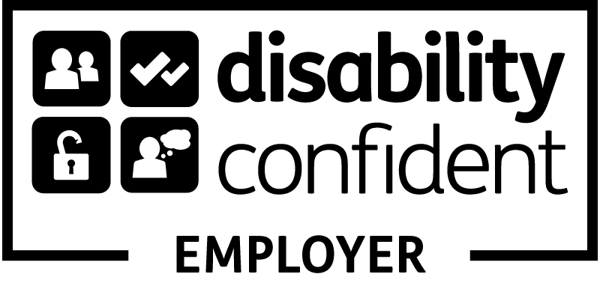
Other, please specify:

Do you have caring responsibilities? If yes, please tick all that apply
None
Primary carer of a child/children (under 18)
Primary carer of disabled child/children
Primary carer of disabled adult (18 and over)
Primary carer of older person
Secondary carer (another person carries out the main caring role)
Prefer not to say

Are you a care experienced adult? Yes/No/Prefer not to say
(Have you been in care?)

Signed ………………………………………………………. Date …………………………

